S_ALR_87012050 -

Functionality
The report displays all acquisition documents in a fiscal year per asset. The following is displayed for each document:
Acquired APC
Acquired quantity
Planned ordinary and special depreciation for the acquisition

Scenario
This transaction is used to display a list of current year asset acquisitions.

Requirements
None.

Menu Path | Accounting → Financial Accounting → Fixed Assets → Information system → Reports on Assets Accounts → Day to day activities → International → S_ALR_87012050 - Asset Acquisitions
Transaction Code | S_ALR_87012050

1. Double Click on S_ALR_87012050 - Asset Acquisitions

Asset Acquisitions

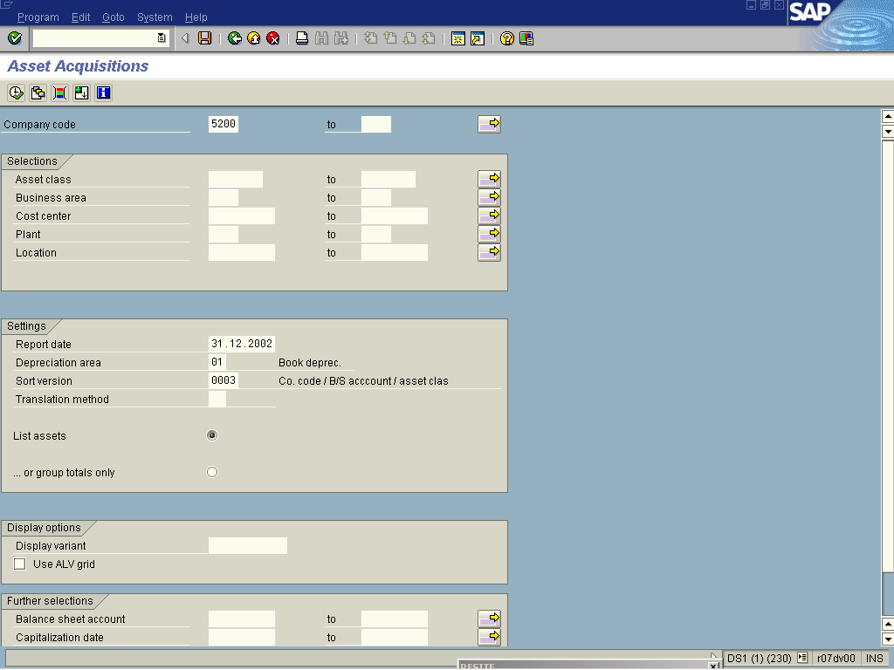

2. Update the following fields:

Field Name | Field Description | Values
Company code | Organizational unit within financial accounting. | Example: 5200
3. Click <radio button> List assets .
4. Click Execute .

Asset Acquisitions

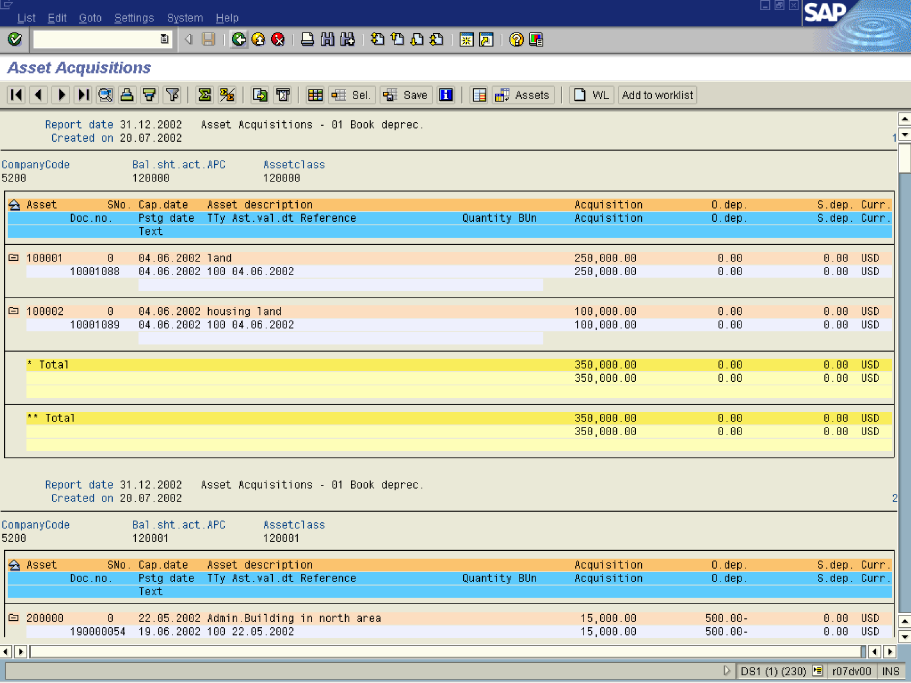

5. The system displays a list of asset acquisitions.

